

April 17-20, 2023
Shenzhen World Exhibition & Convention Center (Bao'an New Venue), PR China
For immediate release
Green, Smart, Advance
3 Hot Technologies in 1 Show at CHINAPLAS 2023
Green, Smart, Advance are the 3 keywords for most of the industries nowadays, including but not limited to plastics and rubber industries. Green is the commitment for circular economy and sustainability. Smart can inspire innovations and enhance user experience. Advance is the powerful tool for improving productivity and quality. At CHINAPLAS 2023, to take place from April 17-20, 2023 in Shenzhen World Exhibition and Convention Center (SWECC), Shenzhen, PR China, visitors will for sure immerse in these 3 hot technologies under one roof, helping inspire new ideas and explore new opportunities.
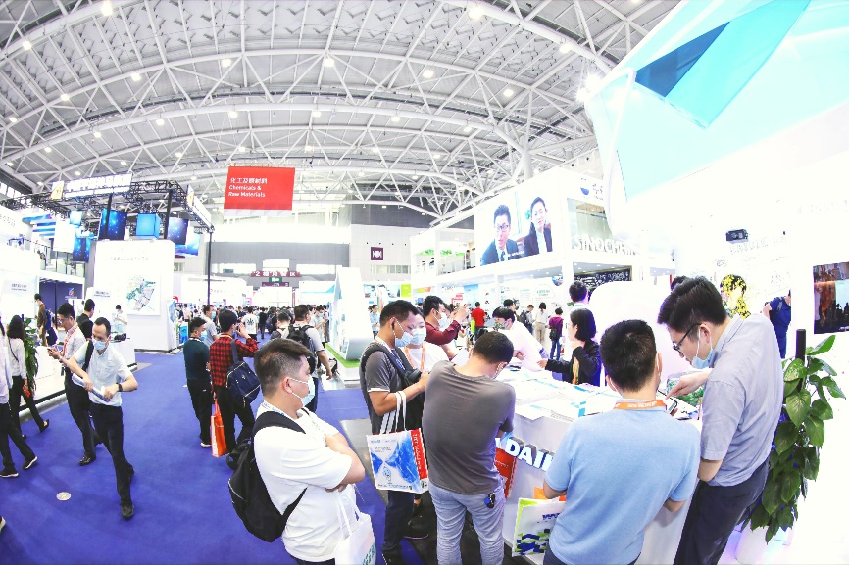
At CHINAPLAS 2023, visitors will for sure immerse in green, smart, and advance technologies in the same occasion under one roof.
Intensifies Innovations Towards a Circular Economy
There is no denying that plastics consumption – especially for single-use plastics – has created a huge challenge to our environment. Plastics industry now spares no effort to intensify innovations towards a circular economy for sustainability development.
The plastics industry has long been applying the linear model, or “take-make-dispose” approach. Circular economy concept aims to reduce the amount of plastic waste generated by applying a “closed loop” system, redesigning how plastic products are taken, made, used and reused to alleviate the plastic waste problem.
One of the main thrusts of circular economy is the increased rate of recycling. Post-industrial waste and post-consumer waste need to undergo recycling in order for them to be re-used. Recycling technologies have seen tremendous improvements in terms of speed, efficiency and cost-saving advantages.
Under the theme "A Brighter and Shared Future, Powered by Innovation", CHINAPLAS 2023 will provide visitors with a whole spectrum of sustainable solutions in 3 theme zones, including Recycled Plastics Zone, Bioplastics Zone, and Recycling Technology Zone. With over 14,000 sqm, 200+ machine makers and materials providers, including Erema, Starlinger, Avian, Tomra, Topcentral, Guolong, NatureWorks, BiologiQ, Ruian are to showcase latest environmentally-friendly plastic materials and processing technologies.

Plastics industry now spares no effort to intensify innovations towards a circular economy for sustainability development.
Plastics and Rubber Industries Go Smart
Industry 4.0, has created a remarkable impact on the production of a huge range of products. Plastics industry, yet having a history of 160 years, also goes smart with cutting-edge technologies for greater efficiency and cost reduction in the era of Industry 4.0.
Through digitalization, manufacturing systems for plastics industry have become much more intelligent. The adoption of smart manufacturing process in all aspects of production – from product design, actual production, supply chain, distribution and sales, and delivery – has made it possible for companies to withstand current and future challenges.
Digitalization has been increasingly applied particularly in plastics production processes. There is growing need for advanced machinery and auxiliary equipment, sensors, process control software and other products to transform a plastics production facility into a smart manufacturing plant.
In the rising trend of digitalization among plastics and rubber industries, CHINAPLAS 2023 will bring together almost 330 solution providers around the world in Injection Molding and Smart Manufacturing Solutions Zone with over 60,000 sqm. Besides international big names like Siemens, Keba, B&R, Beckhoff, Baumaueller, Staubli, Motan, ENGEL, SHI & Demag, Fanuc, Wittmann Battenfeld, etc., plenty of leading Chinese suppliers like Haitian, Chen Hsong, LK Machinery, Borch, Yizumi, CML, Inovance, etc., are about to showcase full array of smart manufacturing solutions and machines at the theme zone, to facilitate the adoption of smart solutions and technologies and achieve the targets of digital manufacturing transformation.
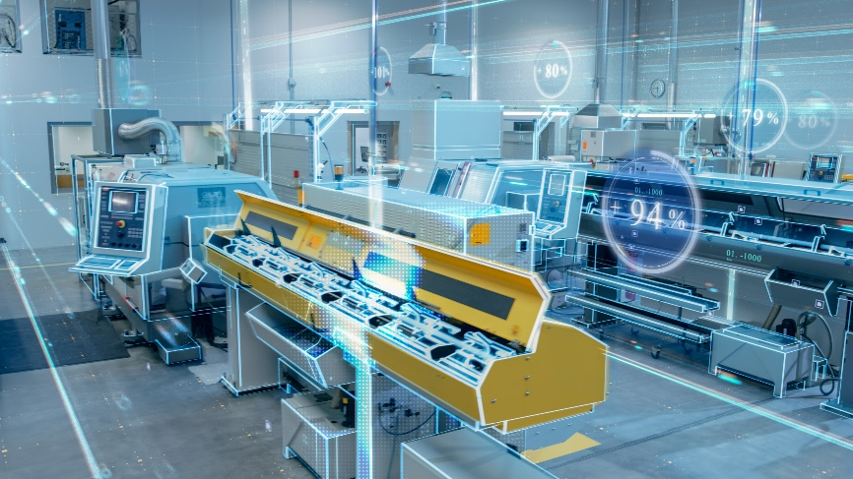
Through digitalization, manufacturing systems for plastics industry have become much more intelligent.
Advance: Automation + 3D Printing
Automation and 3D Printing are the two key enablers for technology advancement. Despite the perception that robots will take the jobs of humans, automation in the plastics industry is not a zero-sum game to decide between an all-human workforce or an all-automated one. A number of plastics processes can apply automation. Investing in automation would be a means to do more with the equipment plastics manufacturers currently have. In the medical devices industry, for example, manufacturer may use automated process to insert plastic parts into a medical component, and measure the cavity pressure to ensure the parts are properly insert.
3D printing, or additive manufacturing, market has seen a tremendous growth and innovation since it is first invented in the early 1980s. After the expiration of a key patent in 2009, allowing many technology companies to offer low-cost consumer-level 3D printers, 3D printing is no longer a niche technology. The global 3D printing plastics market reached USD 786.9 million in 2021 and is expected to grow at a CAGR of 23.9% from 2022 to 2030. Personalization products development and government incentives, coupled with the rising demand from the end-user industries such as automotive, medical, and aerospace, shall boost the market to expand further over the coming years.
Not to mention the advanced automation and robotics technologies in the Injection Molding Solutions Zone, a 3D Tech Zone will also be set up in CHINAPLAS 2023. At the theme zone, visitors shall discover new 3D printing materials, technologies and hardware from Yizumi, Bright Laser Technologies, ZWSOFT, Hanbang, DMAC and other solution providers.
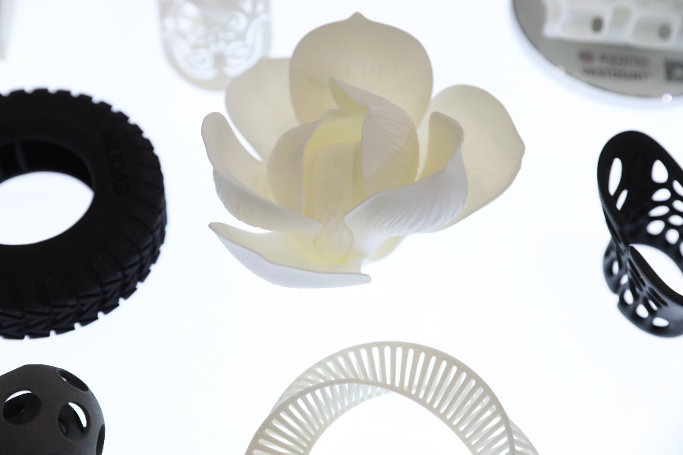
Personalization products development and government incentives, coupled with the rising demand from the end-user industries, shall boost the 3D printing market to expand further over the coming years.
China Relaxes Travel Restriction from 8 Jan 2023
Three years after the border control, China relaxed travel restriction from 8 January 2023. Overseas travelers will only have to show a negative nucleic acid test result obtained within 48 hours and will no longer need to apply health code and quarantine upon arrival, and can enter society directly. China will improve visa arrangements for foreigners and resume the international flights gradually. CHINAPLAS 2023 welcomes the relaxation of border controls and is ready to receive international visitors in Shenzhen.
The Online pre-registration to CHINAPLAS 2023 is open till April 11, 2023, 17:00 (GMT +8:00). Visitors can enjoy an early bird discount at RMB 50 or USD 7.5 (Original Price: RMB 80) for a four-day pass. Pre-registered visitors shall receive their Visitor e-Badge or e-Confirmation Letter in advance for fast entry.
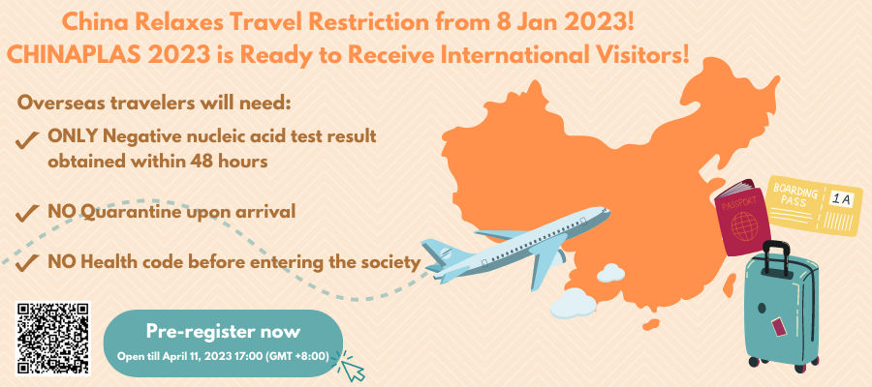
China has relaxed travel restriction. Grasp this chance to scan or click HERE to pre-register CHINAPLAS 2023 now!
Cannot wait to reach ample resources from worldwide plastics and rubber tech suppliers? Visit CPS+ eMarketplace (www.chinaplasonline.com/eMarketplace), the global plastics & rubber solutions e-sourcing platform powered by CHINAPLAS, to serve your sourcing needs.
For more information or enquires about CHINAPLAS 2023, please visit www.ChinaplasOnline.com or contact Chinaplas.pr@adsale.com.hk.
**END**

- Please click on the photo to download the high-resolution image.
- Grateful if we are provided a copy for reference if it is published.
- This press release is issued by Adsale Exhibition Services Ltd.

For media inquiries, please contact:
Hong Kong: Ms. Adele Fung / Ms. Cynthia Lau
Tel: (852) 2516 3316 / 2516 3583
Email: Chinaplas.pr@adsale.com.hk
Official Website: www.ChinaplasOnline.com
CHINAPLAS WeChat:


About CHINAPLAS 2023
CHINAPLAS 2023 is organized by Adsale Exhibition Services Ltd., Beijing Yazhan Exhibition Services Ltd., Adsale Exhibition Services (Shanghai) Ltd., Adsale Exhibition Services (Shenzhen) Ltd. and co-organized by China National Light Industry Council - China Plastics Processing Industry Association, China Plastics Machinery Industry Association, Guangdong Plastics Industry Association, Messe Düsseldorf China Ltd., Shenzhen Polymer Industry Association and the Plastic Trade Association of Shanghai. The event is also supported by various plastics and rubber associations in China and abroad.

First introduced in 1983, CHINAPLAS has been approved by UFI (The Global Association of the Exhibition Industry) since 2006. CHINAPLAS is exclusively sponsored by the Europe's Association for Plastics and Rubber Machinery Manufacturers (EUROMAP) in China for the 32nd time. CHINAPLAS is currently Asia's leading plastics and rubber trade fair.

